Grade 7 Accelerated · Unit 6 · Thread B · Day 1  Angle Pairs: Supplementary, Complementary, Vertical, Adjacent  Independent Set 6.T1 ANSWER KEY | Name  Date  Period

Six questions, on your own, in silence. Show the step that does the work.
1. What is the complement of 61°?
29°
90 − 61.

2. What is the supplement of 76°?
104°
180 − 76.

3. Two lines cross, and one of the four angles is 58°. Find the other three.
122°, 58° and 122°
The vertical angle is equal; each neighbour makes 180 with it.

4. A linear pair measures 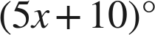 and 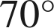. Find x and the first angle.
x = 20; 110°
5x + 80 = 180.

5. Vertical angles measure 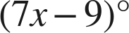 and 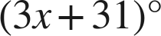. Find the measure of each angle.
61°
7x − 9 = 3x + 31, x = 10.

6. Angles PQR and RQS share the side QR and together make a straight line. Angle PQR is 65°. Name the pair and find angle RQS.
A linear pair (adjacent and supplementary); 115°
180 − 65.

